Comparing Student Learning in a Required Electrical Engineering Undergraduate Course:
Traditional Face-to-Face vs. Online

Carolyn Plumb and Brock LaMeres
Montana State University, Bozeman, Montana, U.S.A.,
cplumb@coe.montana.edu
lameres@ece.montana.edu

Abstract
Engineering education programs are looking for effective ways to more efficiently deliver engineering education to an increasingly heterogeneous customer base, including non-traditional students, some of whom are working full time. Online courses and programs can be one option to meet the needs of this new customer base; however, educators need to ensure that the quality of the educational experience is maintained. Thus, it is important to assess student learning in the online environment. At Montana State University in Bozeman, Montana, the College of Engineering is experimenting with online courses and programs that can be delivered not only to local students who have time constraints but also to students at a distance in one of the largest states in the U.S. One required undergraduate course for electrical engineering students, Introduction to Logic Circuits, has recently been offered in the face-to-face (fall 2010) and online (spring 2011) environments, using exactly the same materials, which are modular materials developed summer 2010 for an online application. The materials were accompanied by an in-person lecture in fall 2010 and a recorded Camtasia Relay lecture spring 2011. At the end of spring semester 2011, we were able to compare the performance of students from each environment in regard to performance on the same homework assignments, quizzes, and final exam. This data offers an assessment of student learning in the two environments. The paper also includes a summary of the course modules.
1. Introduction
Many engineering programs are experimenting (some quite successfully) with online offerings of engineering coursework, both for local students who have time constraints and for students at a distance. Rarely, however, do we see comparisons of student learning and student perception of the learning experience compared for the same engineering course across the two environments. At Montana State University in Bozeman, Montana, we recently had such an opportunity to compare two iterations of a required undergraduate course for electrical engineering student, Introduction to Logic Circuits. The course was offered face-to-face in fall 2010 and online in spring 2011, using the same materials. The materials were accompanied by an in-person lecture in fall 2010 and a recorded Camtasia Relay lecture spring 2011.
This paper reports a comparison of student performance on course quizzes, homework, exams, and final course grades from both iterations of the course.
2. Relevant Literature
The effectiveness of online instruction has been a topic of debate since the early days of distance learning. A recent U.S. Department of Education meta-analysis of 176 online learning studies drew several important conclusions relating to past evidence-based reports of online learning, including that, for older learners, “Students in online conditions performed modestly better, on average, than those learning the same material through traditional face-to-face instruction.” However, other researchers have challenged these results on the basis that the findings in the analysis do “not hold. . .for the studies included in the meta-analysis that pertain to fully online, semester-length college courses.” In fact, these researchers found that for the seven studies in the U.S. Department of Education meta-analysis that related to full-semester college courses, there was no evidence of an advantage or disadvantage to the on-line learning environment. Adding to the inconclusiveness of the evidence for or against gains for online learning is a recent working paper from the National Bureau of Economic Research. This paper describes an experimental study that randomly assigned students in a large introductory microeconomics course to either a face-to-face or an online iteration of the same course. The study showed “modest evidence that live-only instruction dominates internet instruction. These results are particularly strong for Hispanic students, male students, and lower-achieving students.”

Clearly, there is no strong and consistent evidence for the superiority of either instructional mode when used exclusively. However, the U.S. Department of Education meta-analysis found relatively strong evidence that “Instruction combining online and face-to-face elements had a larger advantage relative to purely face-to-face instruction than did purely online instruction.”

The studies discussed so far were based on student learning at many different levels and a broad range of disciplines. A recent study of student perceptions of online learning at a polytechnic university included a fairly large number of engineering and technology students (as well as other students) in a survey of more than 300 students. Their results showed no significant differences in responses from students in engineering and technology majors than students in other majors. This study did not relate to actual learning in online courses, but results showed that students were less comfortable taking a quantitative-oriented course online than they were a qualitative-oriented course. Students also reported that they would be apprehensive about taking a lab-based course online.

A study comparing performance of engineering graduate students in online and face-to-face versions of the same program (a set of courses) showed that the online students, in general, performed similarly to the face-to-face students; however, the range of performance of the online students was greater: “The top three quartiles of AL [online] students. . .had [an] almost equal learning experience with their counterparts [on campus], but the last quartile of AL students struggled more than the campus students.” The researchers also reported that the instructor spent more time per student with the online students than with the face-to-face students. The students in the two versions of the programs showed no significant differences entering the program, being similar in academic background and years since graduation.

A study at the New Jersey Institute of Technology looked at 150 courses, 3,491 students, and 7,701 course enrollments during fall 2003 and spring 2004. Approximately 20% of the course enrollments were in online offerings; the remainder of the enrollments in face-to-face courses were used as a control. These researchers found that student performance for the online offerings “as measured by course grades, was significantly higher than for face-to-face courses.” This is an interesting result, considering the online learning group’s combined average SAT scores were not as high as the face-to-face students. As in the previously discussed study of graduate students, no differences were found between enrollees in engineering courses and those in non-engineering courses.

Another study compared student performance among four different deliveries of an engineering graphics course. One version of the course was face-to-face (14 students), one was synchronous distance education using audiographics technology (20 students), a third was a hybrid of face-to-face with asynchronous (23 students), and the fourth was synchronous online instruction (10 students). The same instructor taught all versions of the course. To determine if there were differences in performance among the four groups of students, all students took a post-test of engineering graphics concepts. The results showed no significant difference in post-test scores of the four different groups.
A study comparing the performance in two versions of a sophomore-level Circuits Analysis course (one face-to-face and one online, delivered via a combination of Tablet PC and Elluminate Live! Software) showed that the performance of the students in the two groups showed no significant difference.

Thus, there is no definitive evidence that online learning delivery methods are naturally better or worse than face-to-face delivery of the same content. More explorations using engineering content will help to add useful information for engineering education practitioners.
3. Description of the Context
EE261 - Introduction to Logic Circuits, is a sophomore-level engineering course that is required of all electrical and computer engineering students at Montana State University. This course is also taken as an elective by computer science students and often other engineering majors. The course is offered every semester and is scheduled to follow a 16-week term. Enrollments are typically between 30-40 students of which about 60% are electrical engineers, 30% are computer engineers, 5% are computer science, and the rest are from various other technical majors with the most common being physics and mechanical engineering.
EE261 is an introductory course and requires only algebra as a prerequisite. It introduces students to the fundamental concepts of classical digital design, including digital signalling, the binary number system, basic logic gate operation, and the transistor level implementation of gates. The course then covers the design and implementation of combinational logic circuits using Boolean algebra and logic minimization using Kaurnaugh maps. Sequential circuits are then introduced as well as finite state machine design. Hardware Descriptions Languages (VHDL) are introduced for the design and simulation of digital systems. The course also covers basic concepts of programmable logic devices and information storage devices.
At the end of this course the student should be able to:
(1) Accomplish number system conversions (decimal, binary, octal, hexadecimal)
(2) Understand Boolean algebra and Karnaugh Maps
(3) Design, analyze, and minimize basic combination circuits
(4) Design and analyze basic sequential logic circuits
(5) Understand operation of basic medium scale integrated circuits
(decoders, encoders, multiplexers, demultiplexers and adders)
(6) Understand concepts of hardware description languages and modern digital design flow.
(7) Describe and simulate combinational logic circuits with a hardware description language.
(8) Be familiar with basic concepts of programmable logic and information storage devices.
At Montana State University, this course is used as an outcome indicator for the ABET outcome (o) An ability to design digital systems using modern design tools.
The course is broken into 8 learning modules. Each module is designed to last an integer number of weeks in order to synchronize to a 16 week schedule with 1 week of break. Modules range from 1 to 3 weeks. Each week, students are provided practice problems with solutions that correspond to the material being covered that week in lecture. Each week, the students are assigned a set of graded homework exercises that are due the following week. There are 15 total homework assignments throughout the semester with each one being worth 2% of the students’ final grade. Homework assignments constitute 30% of the students’ final grade.
Each week, the students are also required to participate in a discussion group in the course management system. Weekly topics are related to historical and worldly issues associated with digital systems. There are 15 total discussion assignments throughout the semester with each one being worth 1% of the students’ final grade. The grading of the discussion is on participation, not on the content of their posting. Discussion postings constitute 15% of the students’ final grade.
At the end of each module, the students are given a quiz. The quizzes test the students on the main concepts of the module. There are a total of 8 quizzes throughout the semester, 1 for each of the 8 corresponding learning modules. The grading weight of the quiz depends on the length of the module. One week modules have a quiz worth 2% of their final grade. Two-week and three-week modules have a quiz worth 4% and 6% of the final grade respectively. Collectively, module quizzes constitute 30% of the students’ final grade.
At the end of the semester, students take a final exam that is worth 25% of their final grade. The following figure lists the topics of the 8 learning modules and the corresponding assignments and time spent per section.
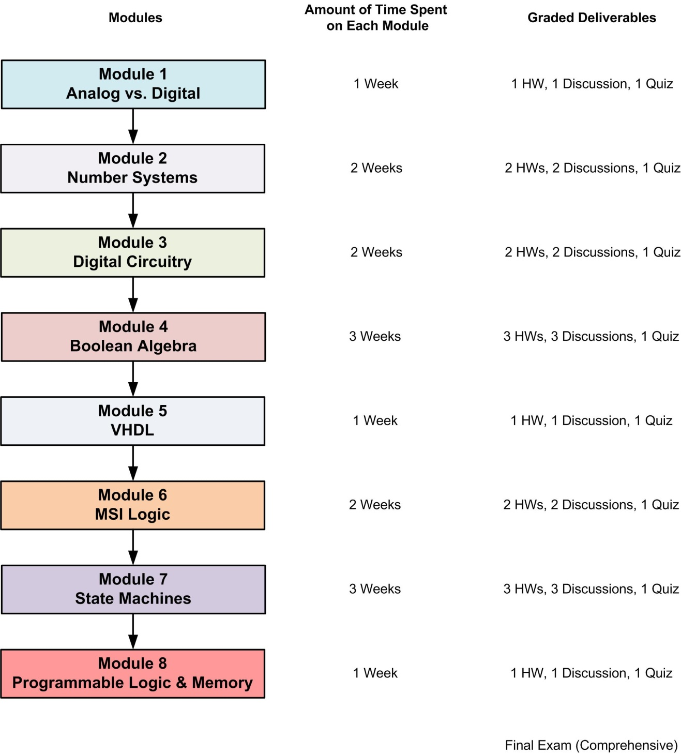

Figure 1. Learning module topics and corresponding time spent and graded deliverables.
4. Results and Discussion
In this section, we present a comparison of the student grades for the various graded components of the course.
The average of the course grades from the two courses was nearly identical: 83.68% for the face-to-face course and 83.72% for the online course. There was no significant difference between the two groups in regard to the final course grade, according to a two-sample t-test. The range of final grades from the fall face-to-face course was 65% to 96%, whereas the range in the spring online course was a bit wider: 60% to 98%. The overall grade point average of students in the fall course (from all of their college coursework to date) was 2.94, whereas the overall grade point average of students in the spring course was 3.02. A two-sample t-test showed no significant difference in the overall college grade point averages of the two groups of students (p = .654). Table 1 below shows all of the grade averages for the work in both courses.

Table 1. Comparison of grades from face-to-face and online courses
 | Fall 2010  Face-to-Face | Spring 2011  Online
Course Grade | 83.68% | 83.72%
Homework | 83.64% | 89.79%
Discussions | 90.77% | 92.00%
Quizzes | 88.21% | 89.28%
Final Exam | 86.61% | 85.88%
ABET (o)* | 88.51% | 97.90%
Module 1 | 95.82% | 95.84%
Module 2 | 87.50% | 90.86%
Module 3 | 69.65% | 77.18%
Module 4 | 87.18% | 82.74%
Module 5 | 72.77% | 83.31%
Module 6 | 85.51% | 72.90%
Module 7 | 77.37% | 82.38%
Module 8 | 93.08% | 88.57%
*The ABET (o) score is a found by averaging 4 homework assignments where students use an engineering simulation tool to design and verify a circuit in addition to a quiz that covers the usage of modern CAE tools. This measure is used as a performance indicator for the program’s outcome “o”.

The graph below shows these comparisons in graphic form.

Figure 2. Comparison of Averages of Graded Components between Face-to-Face
and Online Students

In regard to the separately graded work in the course, the grades on the final exam were very similar (no statistical difference). The individual module scores vary more than other aspects of the course, with some of the scores higher for the face-to-face group and some higher for the online group. Using a two-sample t-test, significant differences between the two groups (at p = .05) were found only for Modules 5 and 6, with the online group scoring significantly higher on Module 5 (p = .047) and the face-to-face group scoring significantly higher on Module 6 (p = .017)

Figure 3. Comparison of Module Grade Averages between Face-to-Face and Online

From Figure 1, comparing performance across time, it does not appear that either face-to-face or online students had a tendency to perform more poorly toward the end of the semester.
5. Conclusions
Previous comparisons, both outside and within engineering, have been inconclusive about whether online learning experiences provide students with an advantage or a disadvantage—or neither. As engineering educators, we are most interested in determining that switching courses from the traditional face-to-face delivery to an online delivery does not compromise student learning. After all, our main purpose in moving to online delivery for some coursework is to accommodate students’ schedules and geographical location.

In this study, which compared two versions of the same required electrical engineering course, Introduction to Logic Circuits, using exactly the same instructional materials, it appears that student learning was not compromised in the online delivery version of the course. Two groups of students whose overall college grade point averages were no different entering the two versions of the course, received nearly an identical average final grade in the course and performed similarly on individual graded components in the course.

References B. Means, Y. Toyama, R. Murphy, M. Bakia, and K. Jones, Evaluation of Evidence-Based Practices in Online Learning: A Meta-Analysis and Review of Online Learning Studies, U. S. Department of Education, Office of Planning, Evaluation, and Policy Development, Center for Technology in Learning, September 2010, page xiv.
A. Jaggars and T. Bailey, Effectiveness of Fully Online Courses for College Students: Response to a Department of Education Meta-Analysis, Community College Research Center, Teachers College, Columbia University, New York, 2010, p. 1.
Ibid., p. 10.
D. Figlio, M. Rush, and L. Yin, Is It Live or Is It Internet? Experimental Estimates of the Effects of Online Instruction on Student Learning, Working Paper 16089, National Bureau of Economic Research, Cambridge, MA, June 2010, p.1.
B. Means, Y. Toyama, R. Murphy, M. Bakia, and K. Jones, Evaluation of Evidence-Based Practices in Online Learning: A Meta-Analysis and Review of Online Learning Studies, U. S. Department of Education, Office of Planning, Evaluation, and Policy Development, Center for Technology in Learning, September 2010, page xv.
C. Scherrer, R. Butler, and S. Burns, “Student Perceptions of On-Line Education,” Advances in Engineering Education, Summer 2010, accessed online 4/28/2011 at http://www.asee.org.
K. Varde, “An Assessment of Performance and Learning Experience of Students in a Distance-Learning Program, Proceedings of the Annual Conference of the American Society for Engineering Education, June 2007.
J. Carpinelli, R. Calluori, V. Briller, E. Deess, and K. Joshi, “Factors Affecting Student Performance and Satisfaction in Distance Learning Courses, Proceedings of the Annual Conference of the American Society for Engineering Education, June 2006.
M. Holdhusen, “A Comparison of Engineering Graphics Courses Delivered Face to Face, On Line, Via Synchronous Distance Education, and in Hybrid Formats,” Proceedings of the Annual Conference of the American Society for Engineering Education, June 2009.
A. Enriquez, “Assessing the Effectiveness of Dual Delivery Mode in an Online Introductory Circuits Analysis Course,” Proceedings of the Annual Conference of the American Society for Engineering Education, June 2010.

